Curriculum vitae
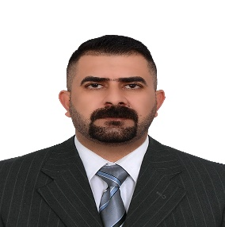

- Full name: Taif Saad Bustan Mahmood
- Date of Birth: 28/06/1991
- Qualification: Master degree
- General specialization: MA. Linguistics
- Title: Asst. Lecturer
- E-mail: taif@uodiyala.edu.iq
- Bachelor's Degree Donor: Diyala University
- Master's Degree Donor: University of Kerala
- Title of Master thesis: The Role of Linguistics On Arabic‒ English Google Translation
- Title of doctoral dissertation: /
- Jobs filled:
From-To | place | Job | N

- WORK EXPERIENCE
NOTES | From- To | College\institution | N

